* Gust sensitivity
* Slightly negatively buoyant
* Stubby wings

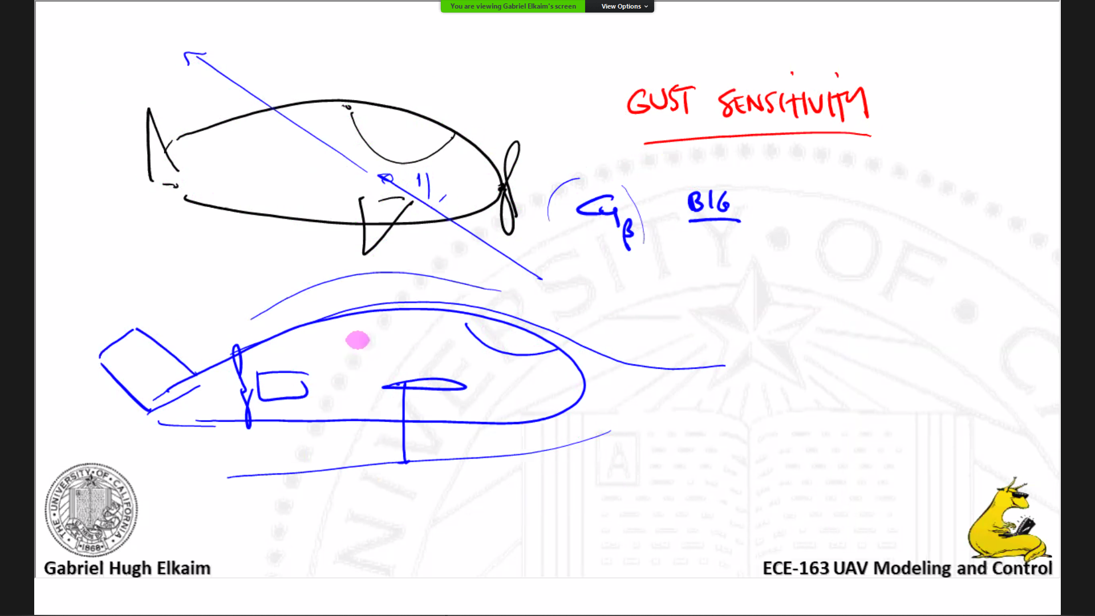

* It will be hella big
* Stubby wings like a blimp
* Minimize drag
* Long slender wings (non buoyant idea)
* Use helium as fuel (probably in efficient)